

**Epic Voting System Report**

**1. Main Interface**

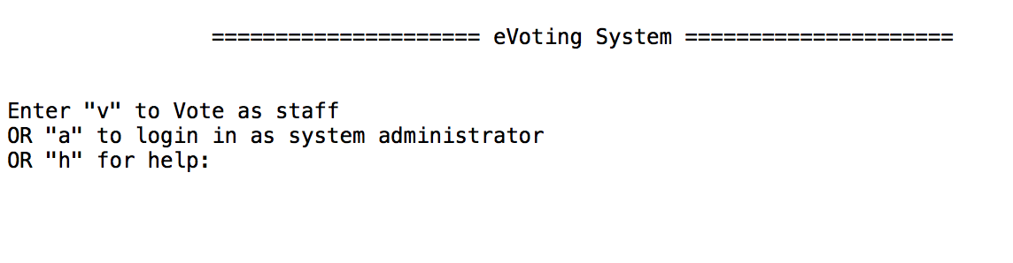

When start to run the system, the default interface is shown as above. User can operate according to remind by entering “v” to Voting system, “a” to Administrator system and “h” to Help function. Voting system is only available to enter after system administrator setting the voting time or voting time range. Or it will show message:

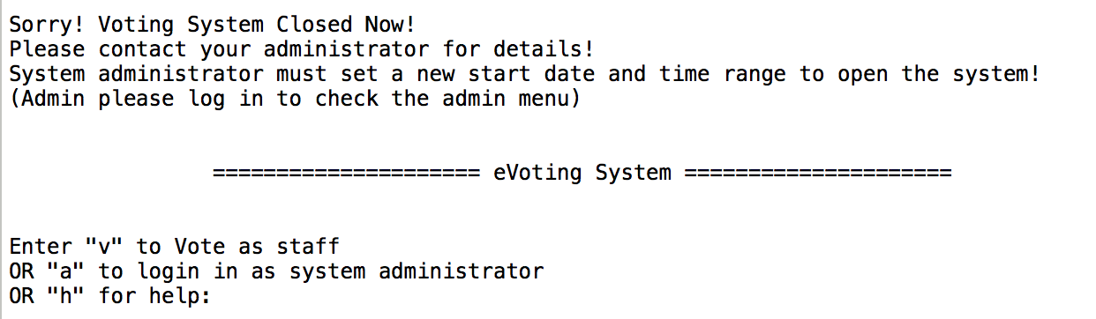

By entering “h”, the Help menu will show up. Help menu is hard coded into the codes. Help menu offers some frequent questions and answers.

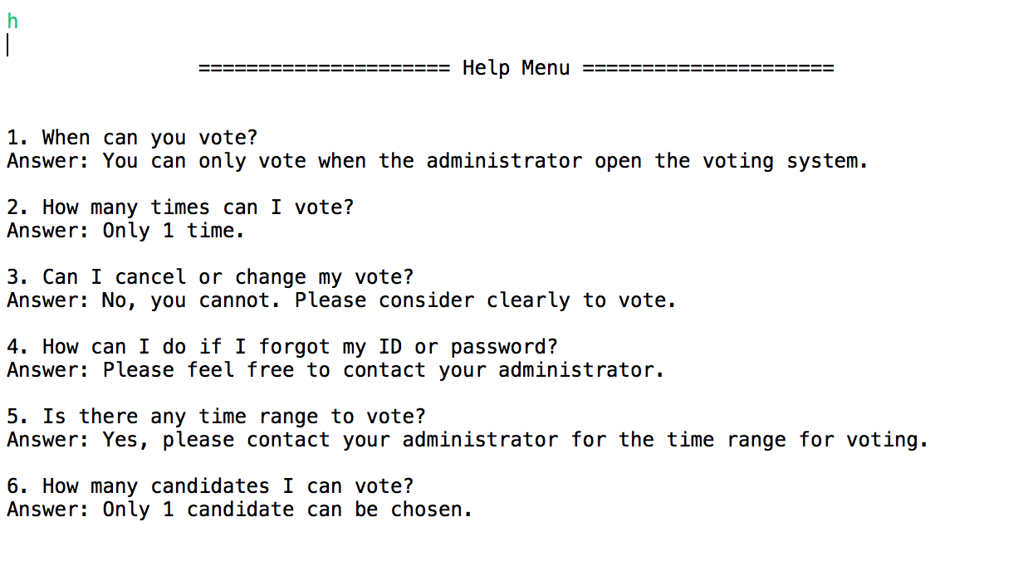

By entering “a”, the interface will switch to admin login page, the administrator can enter account name and password according to reminding message. This iteration has changed the admin from hardcode to admin.txt document. The admin account details are saved in the document named admin.txt including ID, admin name, admin account name, admin account password.

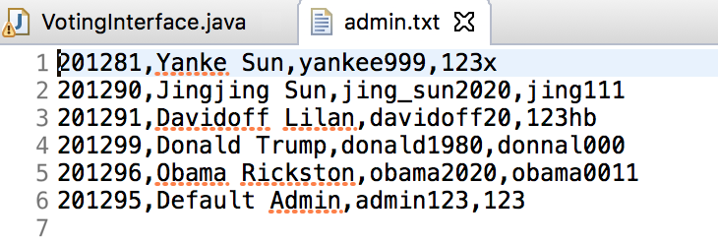

If the admin entered wrong account name or password, it will give corresponding error message as below. Notice, if account name or password are entered wrongly more than 3 times, the system will quit and back to default main interface. If the admin enter “q”, the system will quit to main interface as well.

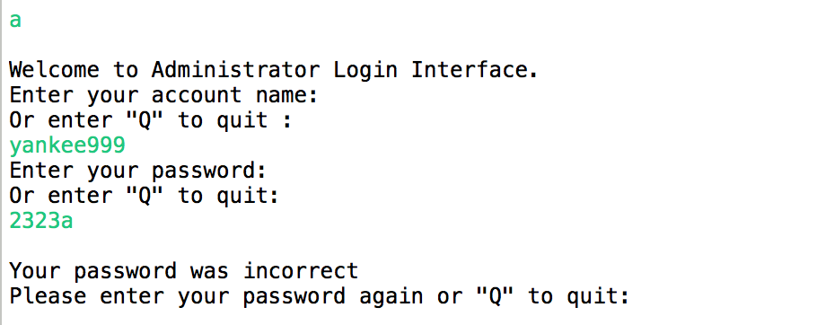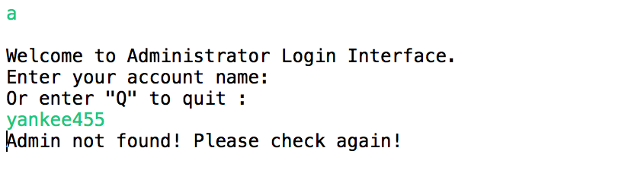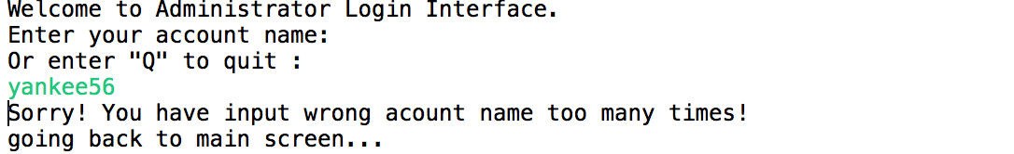

If account name and password are correct to pass the validation, then the admin will enter the administrator space. The screen will show the admins’ name and the admin menu.

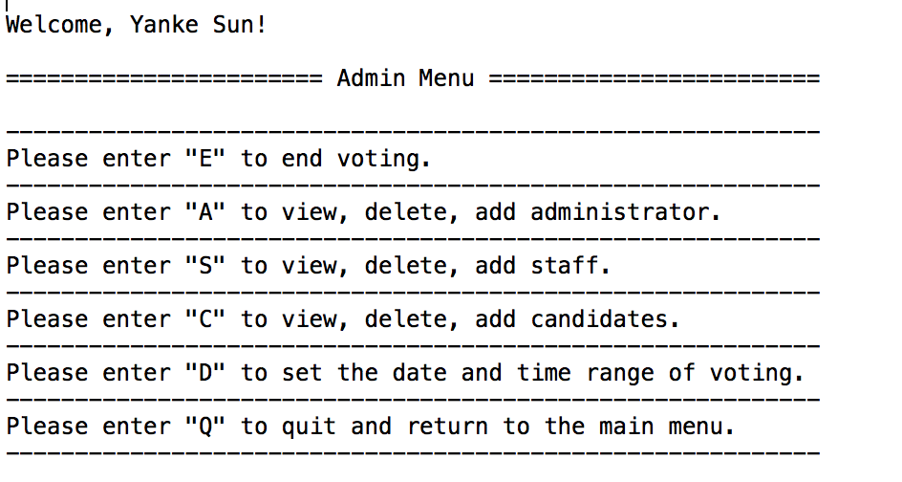

1. **Admin Interface**

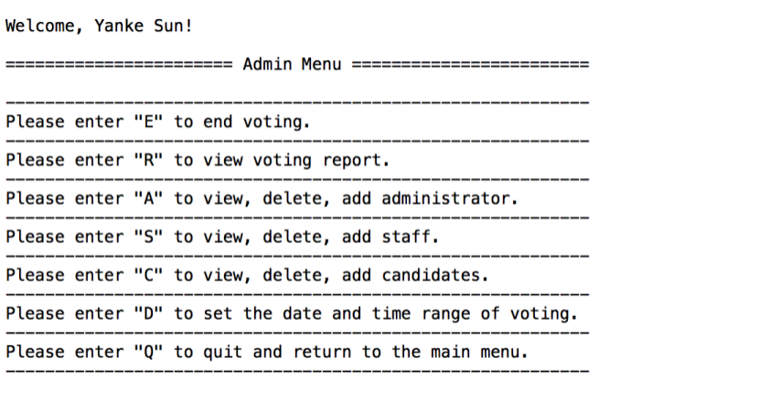

By entering “E”, the admin can close the voting system; staff won’t be able to log in to vote until admin operate again to set new time for voting.



By entering “R”, the admin can get into the interface to view Statistic Voting Report. The report will show every candidate’s votes, the total numbers on voting list and the number and percentage of who have voted.

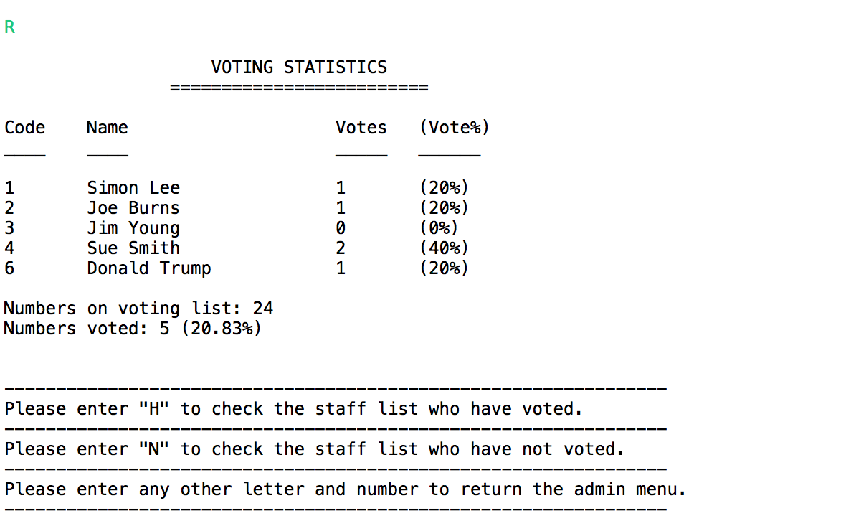

By entering “H”, the admin can see the report of staffs who have voted. It will show the staff’s ID, name and timestamp of voting. Any wrong input will be recognized as wrong input to remind to input again.

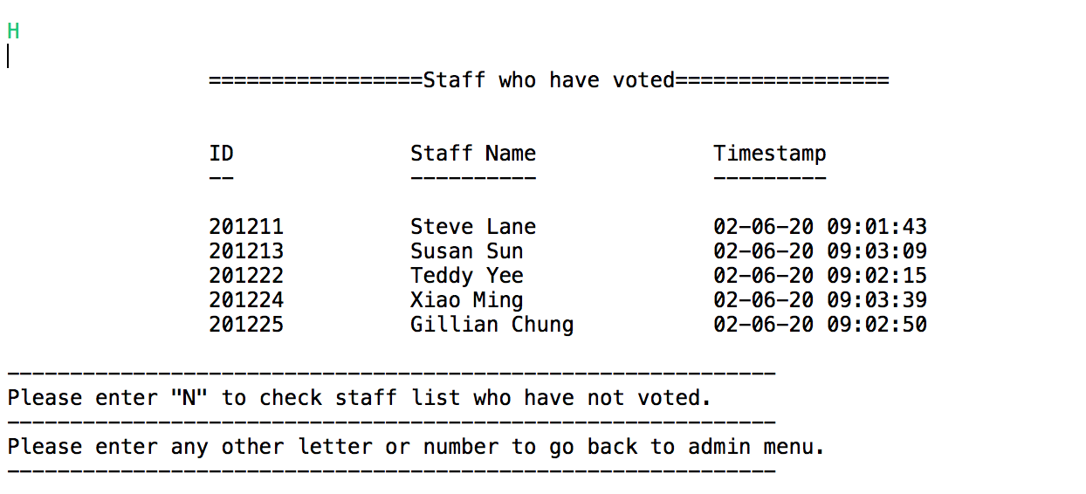

By entering “N”, the admin can view the report of staff who have not voted. The report will include the staff’s ID and name. The admin can enter any other buttons to back to admin menu.

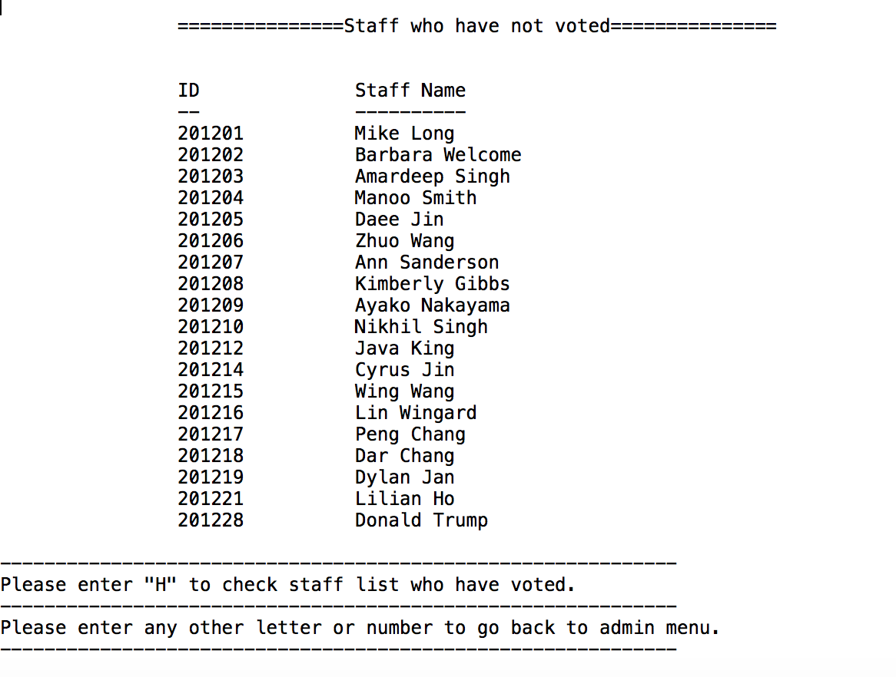

After returning to admin menu page, the admin can input “A” to enter the administrator list page, the admin can view, delete and add new administrator. Notice that all information must be kept well. Because the hard-coded password for administrator, has been deleted from system to promote the security. Now all administrators’ information including password is kept in document of admin.txt.

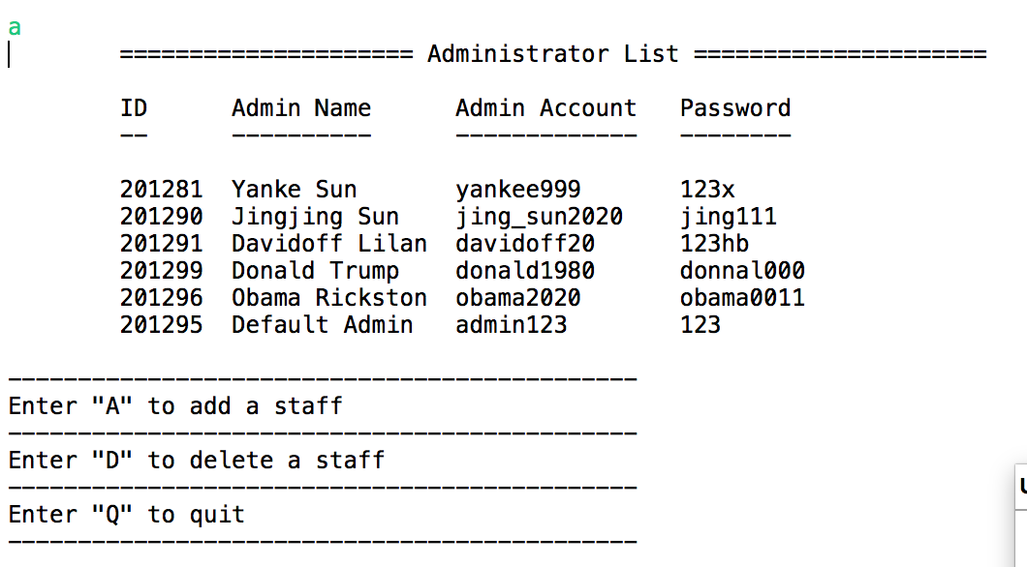

By entering “A”, the admin can operate to add a new administrator, step by step to enter the information the system needs. If the ID input exists in system, then the system will show error message. The name added should have first name and last name, with a space separating them and should not have special symbols and numbers. Account name is allowed to use letters, numbers and “_” “-”. The password should be more than 3 characters. When all filled with correct forms, the new admin account will be added into the admin list. And show up in the admin.txt.

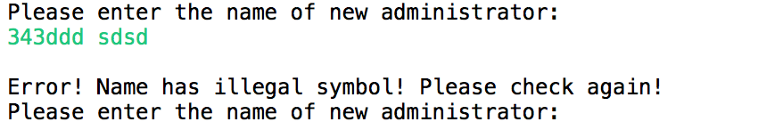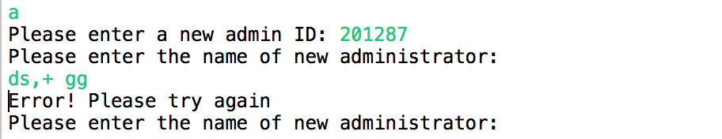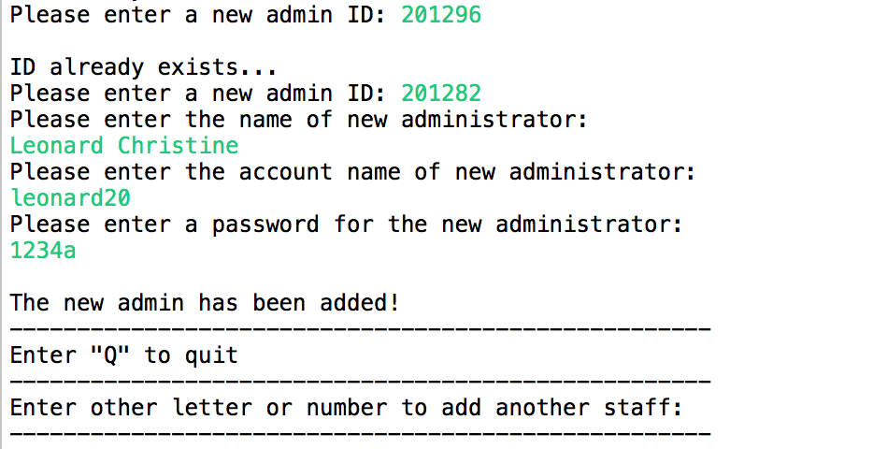

Entering “q” to quit adding function, and back to previous page, the admin can enter “D” to conduct the function of deleting an admin account. The admin will need to enter an existing admin ID to delete, if the data input is not in system, then it give error message.

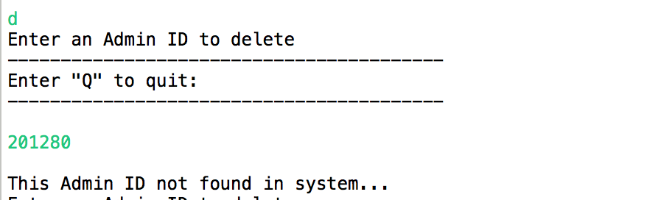

After entering correct Admin ID, the system will show corresponding admin account details, including name, ID, account name to confirm with the admin. If the admin confirms to delete the admin by entering “Y”, the system will show message “This administrator has been deleted”. And the data will be deleted from admin.txt as well. However, the operation can be canceled if the admin enter other letters or symbols instead of “Y”.

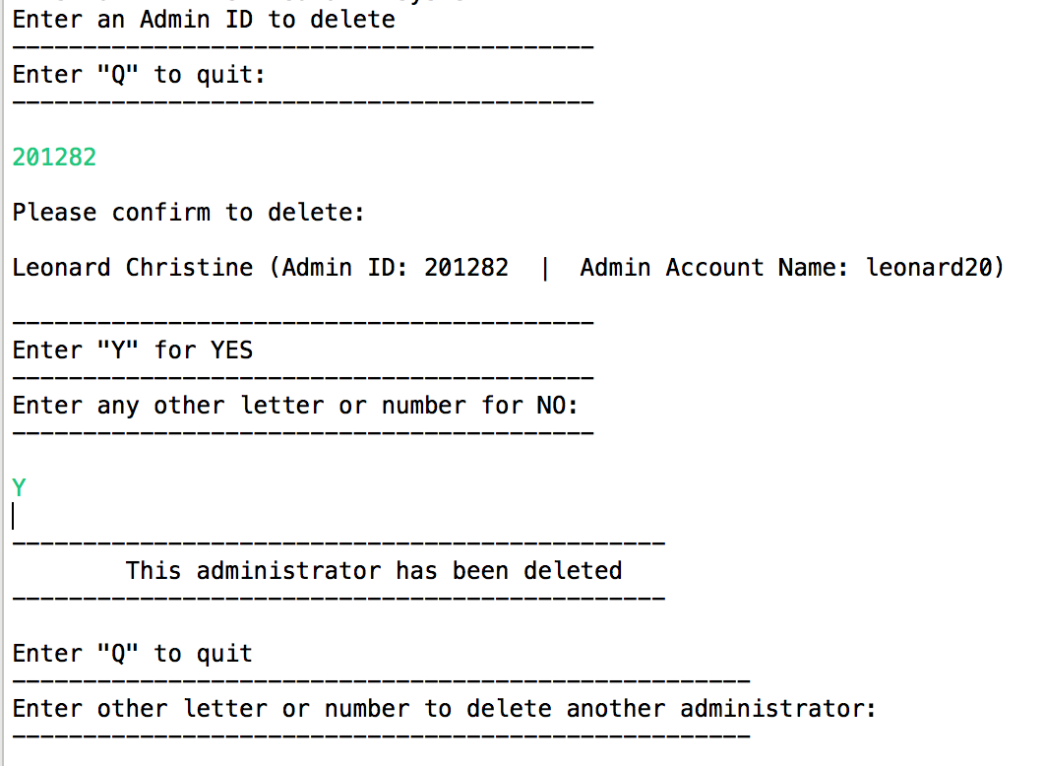

After entering “q”, the admin will quit and back to previous Admin Menu.

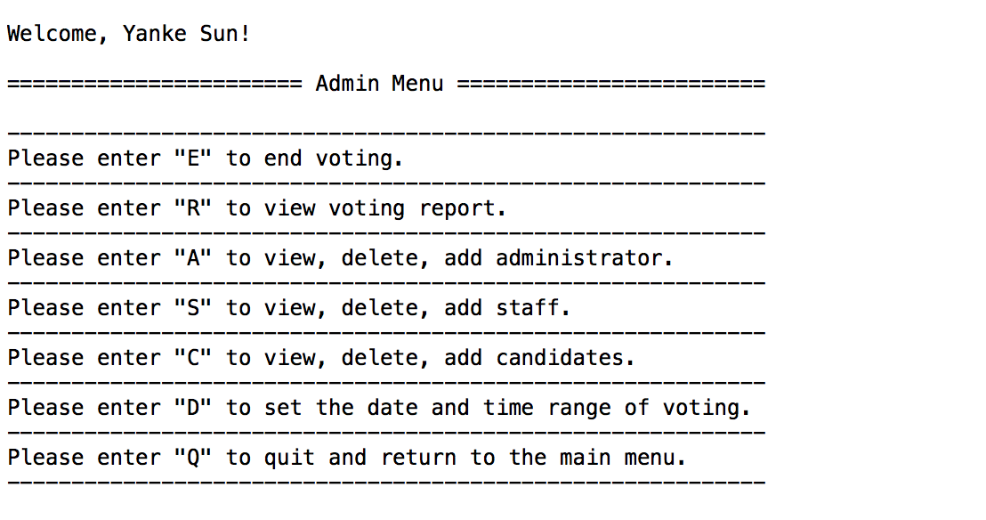

By entering “S”, the admin can implement the functions of viewing, deleting and adding a new staff. The admin can enter “A” to add a new staff, enter “D” to delete a staff and “Q” to quit.

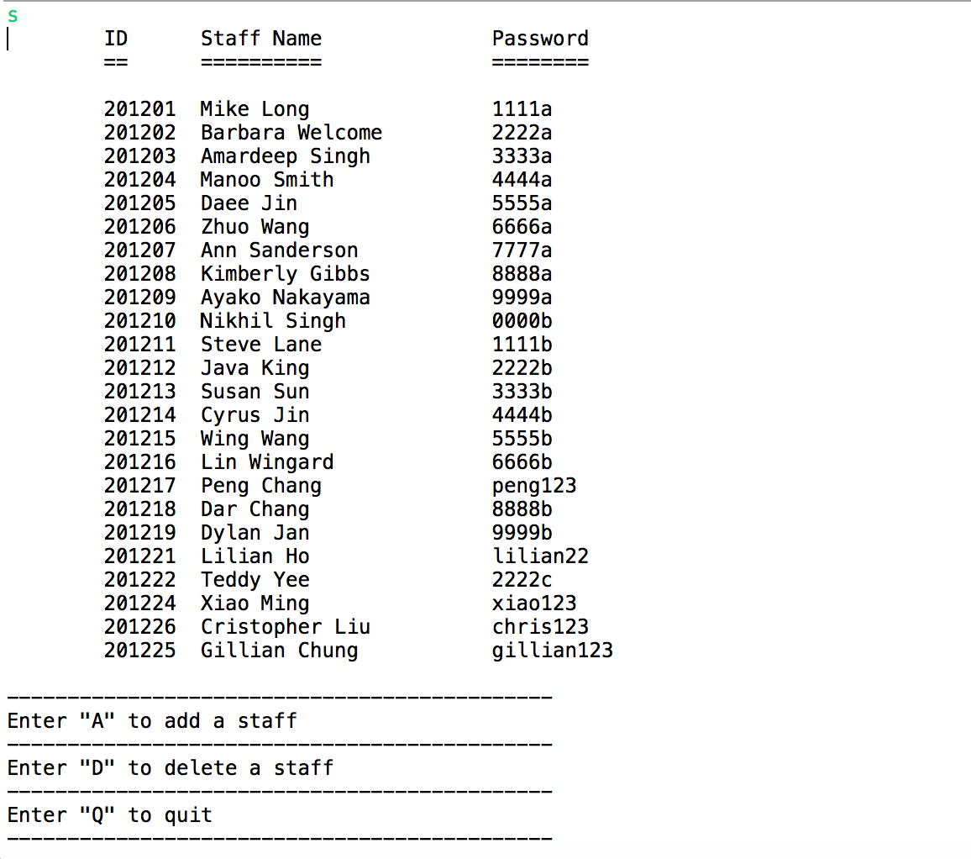

By entering “A”, the admin will start to add a new staff step by step according to the reminding message. This process is similar as last Add-admin process. If the ID input exists in system, then the system will show error message. The name added should have first name and last name, with a space separating them and should not have special symbols and numbers. The password should be more than 3 characters. When all filled with correct forms, the new staff will be added into the staff list. And the document of staff.txt will update as well.

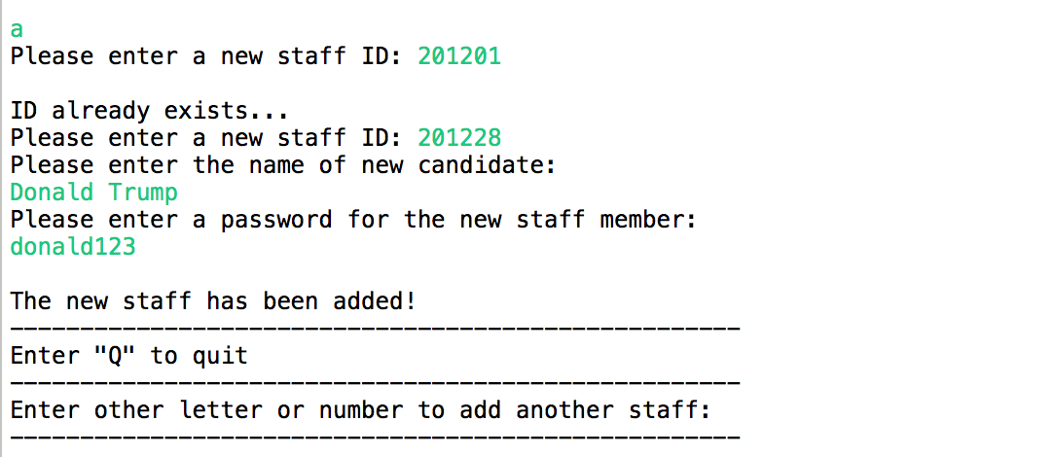

After entering “Q” to quit and back to previous page, the admin can continue other operations such as delete. By entering “D”, the admin can delete a staff from list. As the process in deleting admin, if admin enters a wrong ID number, the system won’t pass and gives error message. If the ID is in system, then it will show the staff details including name and staff ID to confirm the staff information. By entering “Y”, the admin will confirm deleting the staff. After deleting, the staff will be deleted from list and the document of staff.txt.

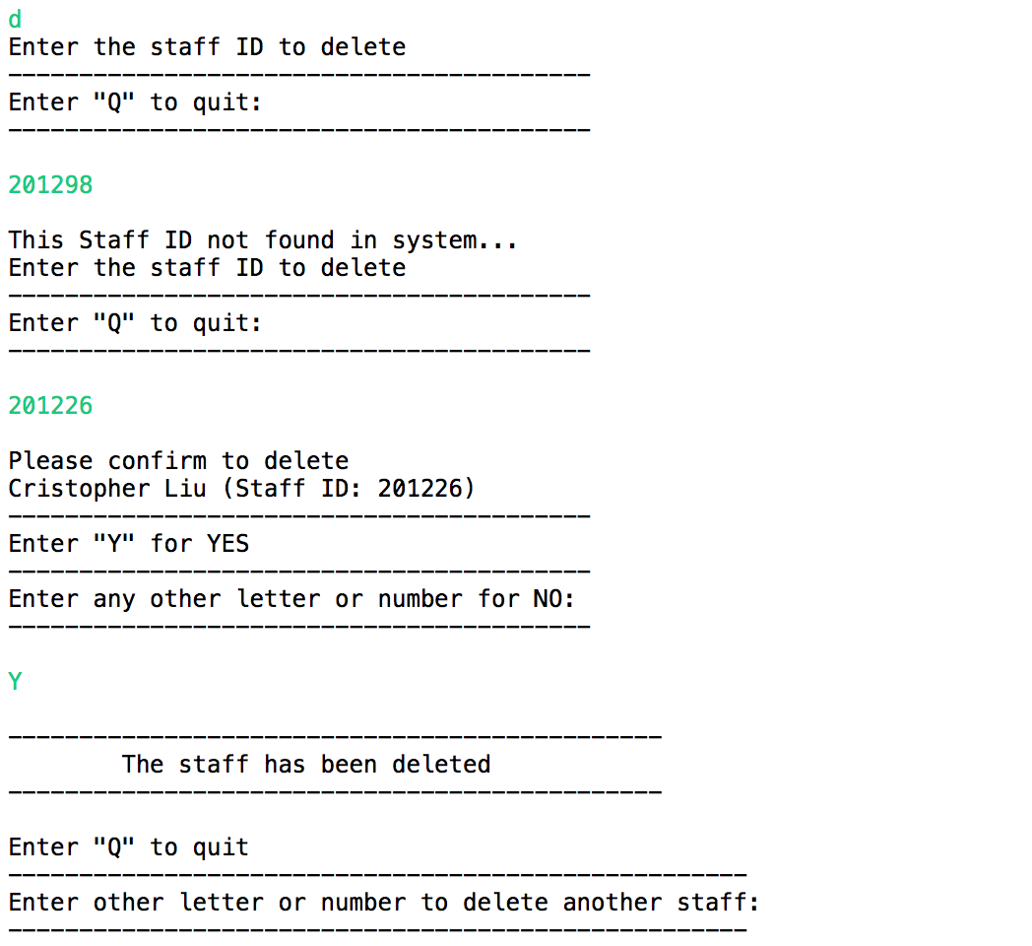

After entering “q”, the admin will quit and back to previous Admin Menu.



By entering “C”, the admin can implement the functions of viewing, deleting and adding a new candidate. The admin can enter “A” to add a new candidate, enter “D” to delete a candidate and “Q” to quit.

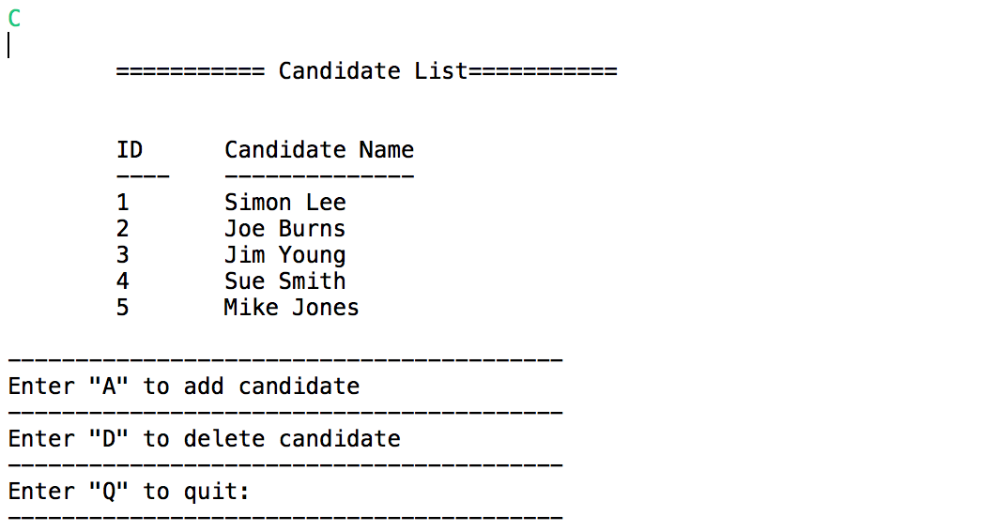

By entering “A”, the admin will start to add a new candidate step by step according to the reminding message. This process is similar as last Add-admin process. If the CODE input exists in system, then the system will show error message. The name added should have first name and last name, with a space separating them and should not have special symbols and numbers. When all filled with correct forms, the new candidate will be added into the candidate list. And the document of candidate.txt will be updated as well.

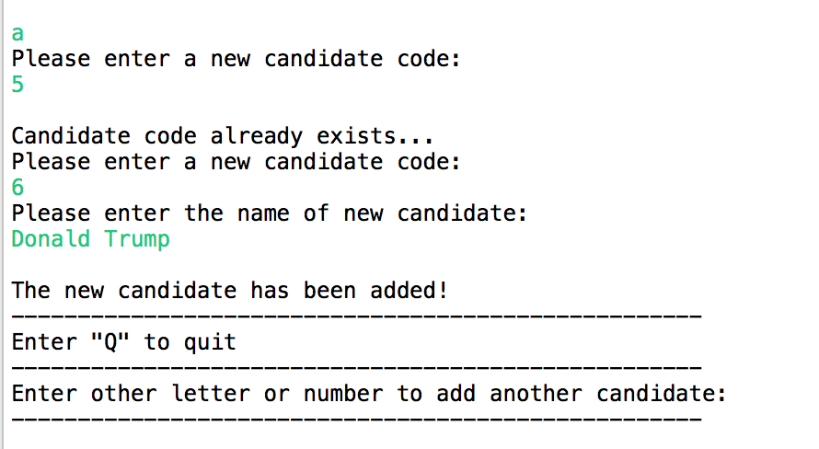

After entering “Q” to quit and back to previous page, the admin can continue other operations such as delete. By entering “D”, the admin can delete a candidate from list. As the process in deleting admin, if admin enters a wrong candidate CODE, the system won’t pass and gives error message. If the ID is in system, then it will show the candidate details including name and candidate code to confirm the candidate information. By entering “Y”, the admin will confirm deleting the candidate. After deleting, the candidate will be deleted from list and the document of candidate.txt.

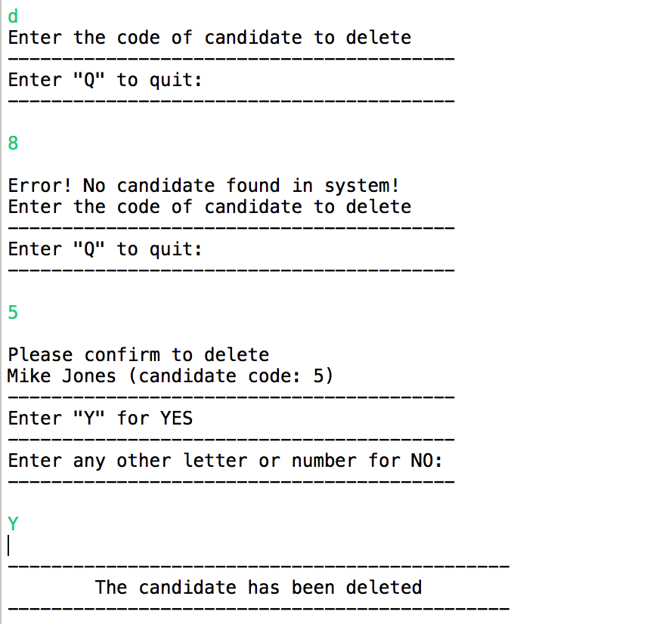

After entering “q”, the admin will quit and can back to previous Admin Menu.



By entering “D”, the admin can switch to the interface for setting the date and time range for voting. After setting the date and time range, the voting system can be available for staff to vote. Enter “Y” to confirm to set new time.

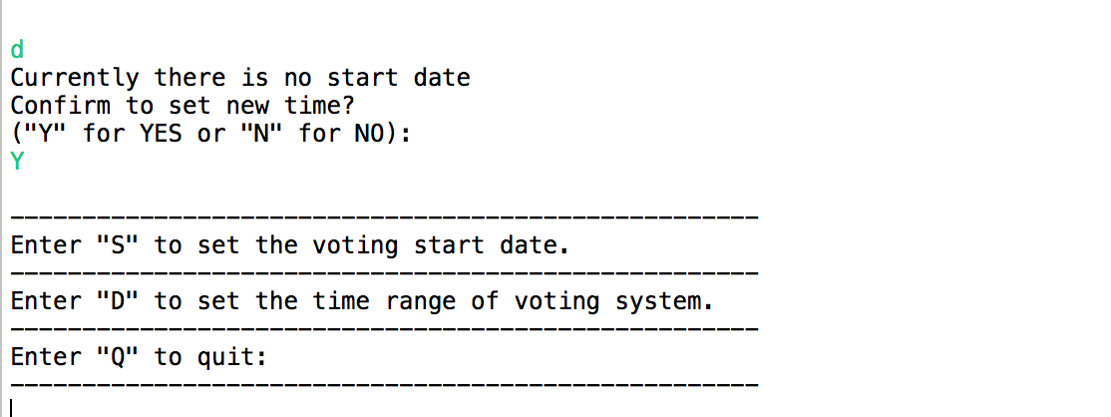

By entering “S”, the admin can get into the function to set the voting time. The time setting can be done step by step based on the reminding messages of system. Firstly, the admin will need to enter the year, the year must be a number between 2019-2099. Or system will give error message

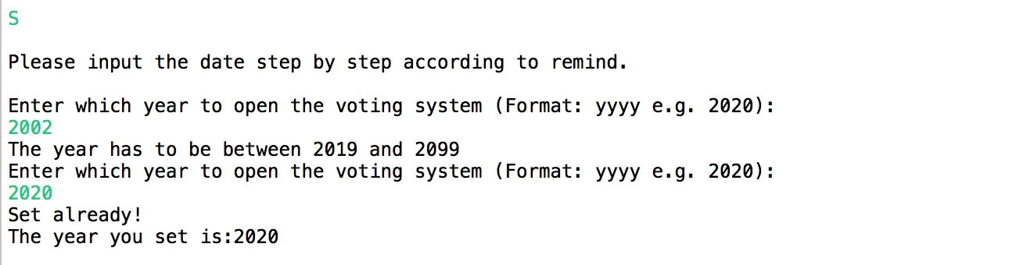

Then the admin can continue set the month and day. System has given the format example already. Month has to be a number between 01-12, and day must be a number between 1-31. Wrong input will be marked as wrong input.

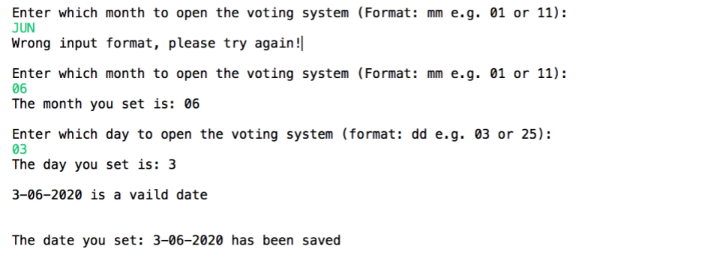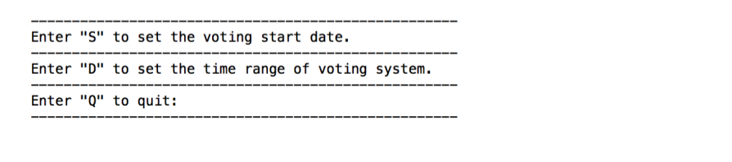

After setting the voting date, if the date is entered in correct format, then it will be saved in system. The voting system will start according to the date which is set. After setting the start date, the admin can continue setting the time range of voting system by entering “D”. The admin can input any number equals or larger than 1. Wrong input format will be marked as illegal input.

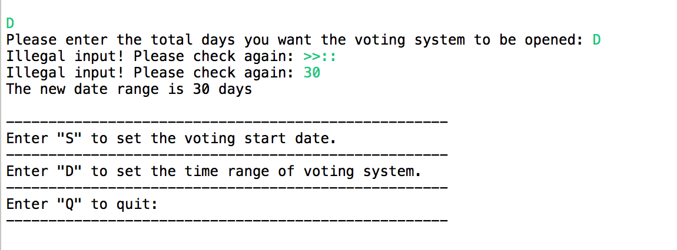

The admin finally can enter “Q” to quit and back to main default page.

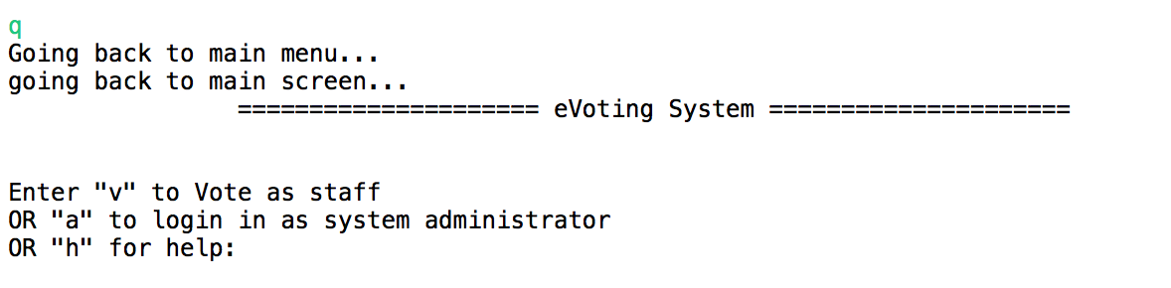

1. **Staff Interface**

After setting the voting time and time range, the voting system is available for staff to vote. The staff can enter “V” to get into Staff Voting System. All staff details are saved into the document of staff.txt. The staff details include staff ID, name, if voted (0 equals not voted; 1 equals voted), password, voted time (if staff has voted, there will be a timestamp in system to mark the voting time).

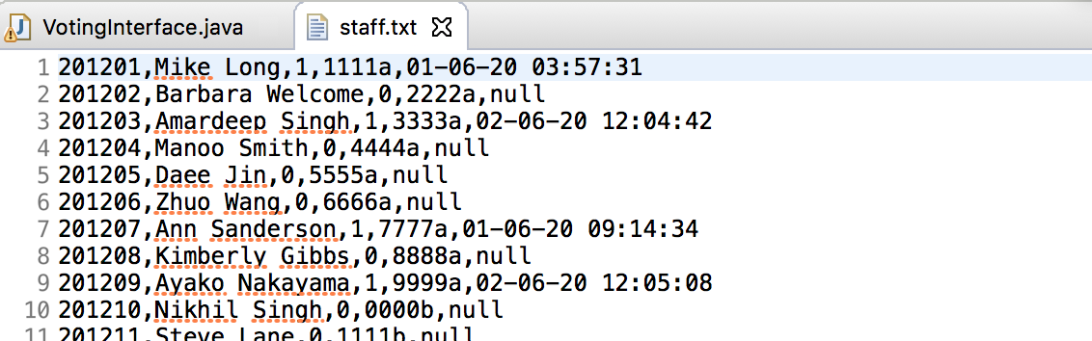

By entering “V”, the staff can get into the log in interface. The staff will need to input staff ID. If the ID input is wrong, there will be error message. If the times the staff tried are more than 3 times, then the system will quit and back to main default page. The password input is same, if wrong input is more than 3 times, the system will quit as well.

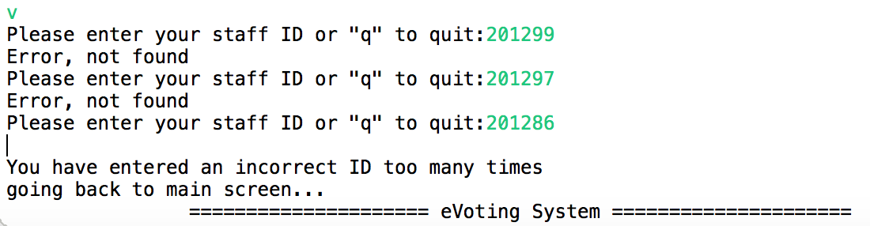

After entering the correct staff ID and password. The staff will enter the voting interface with a greeting of the staff’s name and the candidate list.

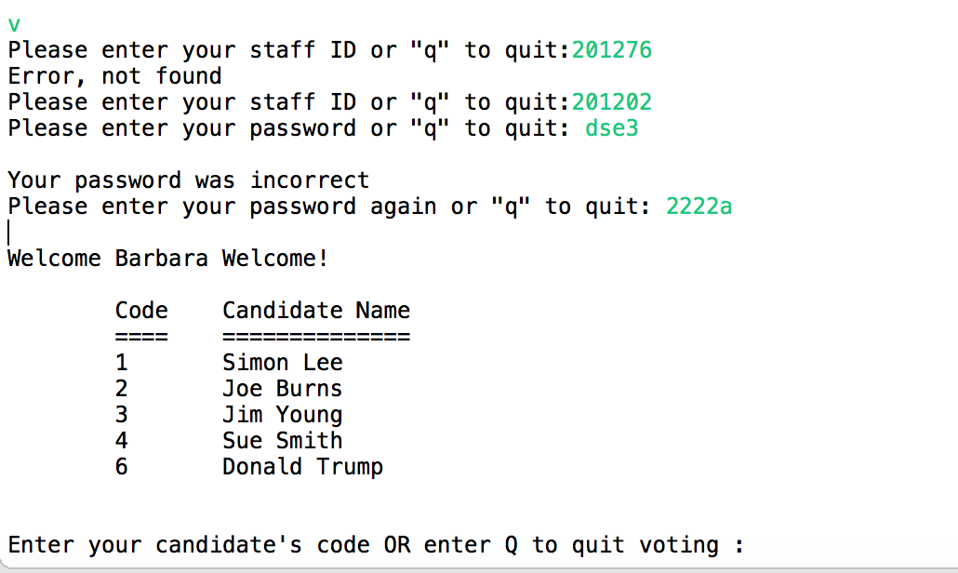

Enter the code of candidate; the staff can start to vote. Only the code number in list can be entered. Other wrong format and number will be recognized as wrong input. After entering correct code number, the system will remind to confirm voting by inputting “Y”. After confirming, the voting will be done. Both of the documents of staff.txt and candidate.txt will update.

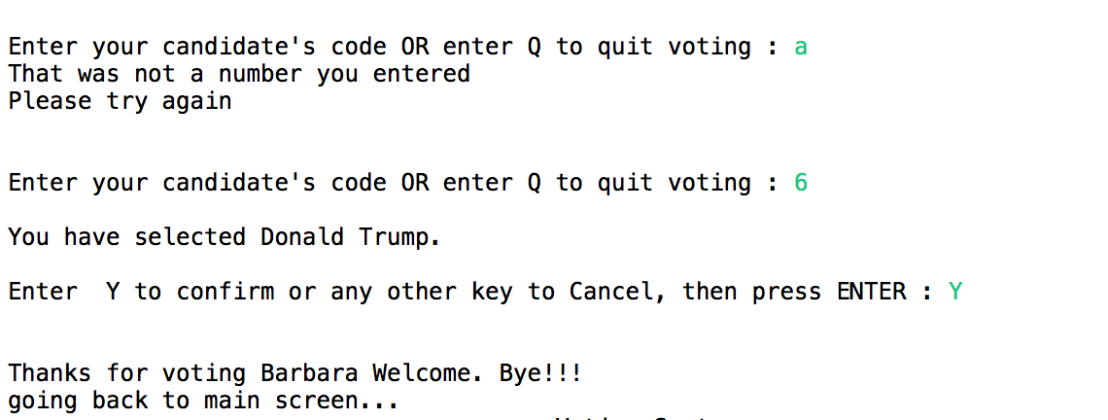

After voting, the system will quit automatically. If the staff logs in again, the system will remind that the staff has voted already, won’t be allowed to log in to vote again.

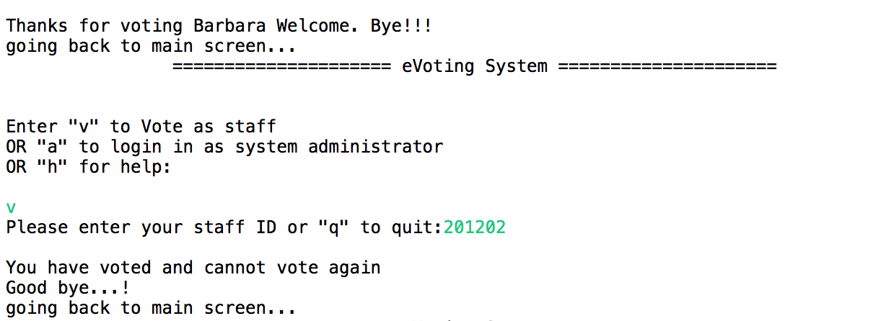

**4. Task List**

|  |  |  |
| --- | --- | --- |
| No. | Functions need to be completed | Achieve or Not |
| 1 | Staff class is modified correctly, to store information for password and date of voting. | √ |
| 2 | User is prompted to enter the staff id & password.  User input must be validated. An appropriate error message is displayed if this check fails and the user is prompted to re-enter. | √ |
| 3 | If a non-existent staff id is entered more than 3 times the system goes back to the main screen. | √ |
| 4 | System checks for a staff who has already voted.  If the staff has voted already, an appropriate message is displayed and program reverts to main screen | √ |
| 5 | System records date for when staff voted correctly | √ |
| 6 | System checks date correctly to ensure voting can only take place within the 7 days voting period allowed. | √ |
| 7 | If the staff is eligible to vote, a list of candidates are displayed and with a prompt to enter the candidate code. | √ |
| 8 | The program asks the staff to confirm the candidate selection before updating the vote. If the staff cancels the selection, the program reverts to the candidate list. | √ |
| 9 | On updating the vote, the program displays a confirmation message and reverts to the main screen. | √ |
| 10 | This transaction is saved to file – candidate vote count is incremented by one, staff voted status is set to true and date of voting is recorded. | √ |
| 11 | If the staff or candidate data file cannot be written to, an appropriate error message is displayed. | √ |

|  |  |  |
| --- | --- | --- |
| 12 | System administrator details (id, name, username & password) stored and retrieved from file. | √ |
| 13 | Upon a successful login, system administrator will have options to see voting results as well as options to update candidate, staff and admin accounts. | √ |
| 14 | System administrator can add, view and delete admin account from the list stored in admin.txt” file. | √ |
| 15 | System administrator can view, add and delete staff information | √ |
| 16 | System administrator can view, add and delete candidate information | √ |
| 17 | System administrator can add, view and update the date range for voting can take place. | √ |
| 18 | System administrator can produce report to display the voting results (display candidate code, name, department and showing total number of votes for each candidate as well as statistical percentages (total and for each candidate) | √ |
| 19 | System administrator can produce report for list of staff that have voted (including date voted) and staff that did not place a vote. | √ |

1. **Conclusion**

All functions required for the epic voting system Iteration 2 have been implemented. But there are still some defects with the codes. And it can be improved in next iteration. For example, the Help Menu is hard-coded into the codes. In the 2nd iteration, the requirements may be not much complicated, so the help function is hard-coded to be easier to operate. But in the long run, it needs to be changed. Besides, the date setting for users is not intelligent enough. For the month input must be a double-digit. For example, if the month the user set is March, then the user should input 03 instead of 3 or Mar. Though the system has reminded users the format of input, it is still a part needs to be improved in the next iteration. User can input 03, 3, Mar, March, various formats should be legal to use. Furthermore, the unit test should cover more details, and operating interface still has some space to improve for users in next iteration.